Docker Compose Project

Code for a React Project:

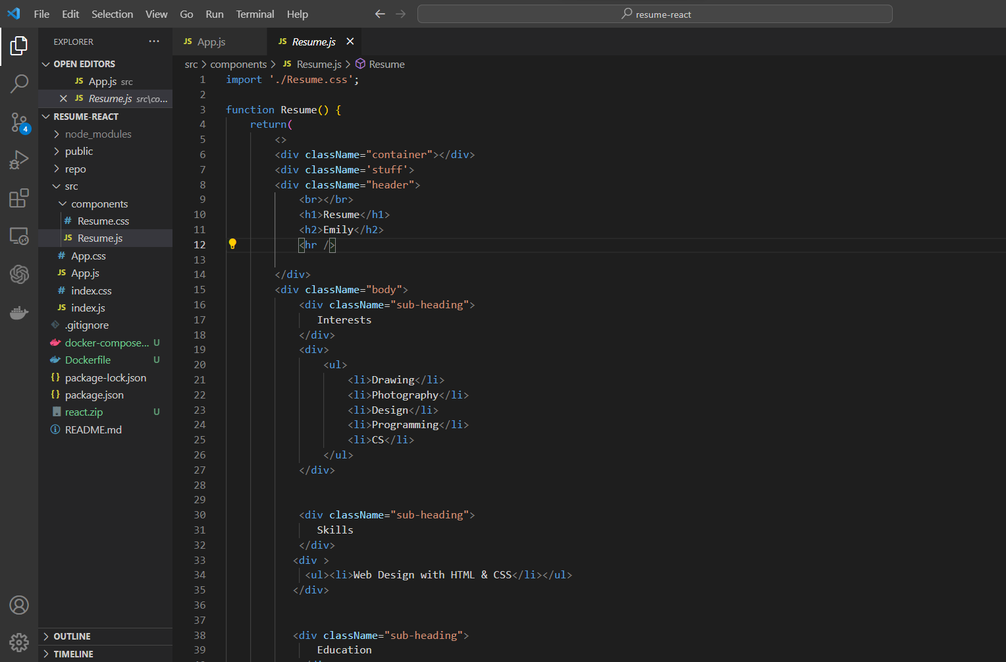

**Dockerfile for this Project:** This Dockerfile will build the image for the react project that will be used by Docker Compose to deploy containers.

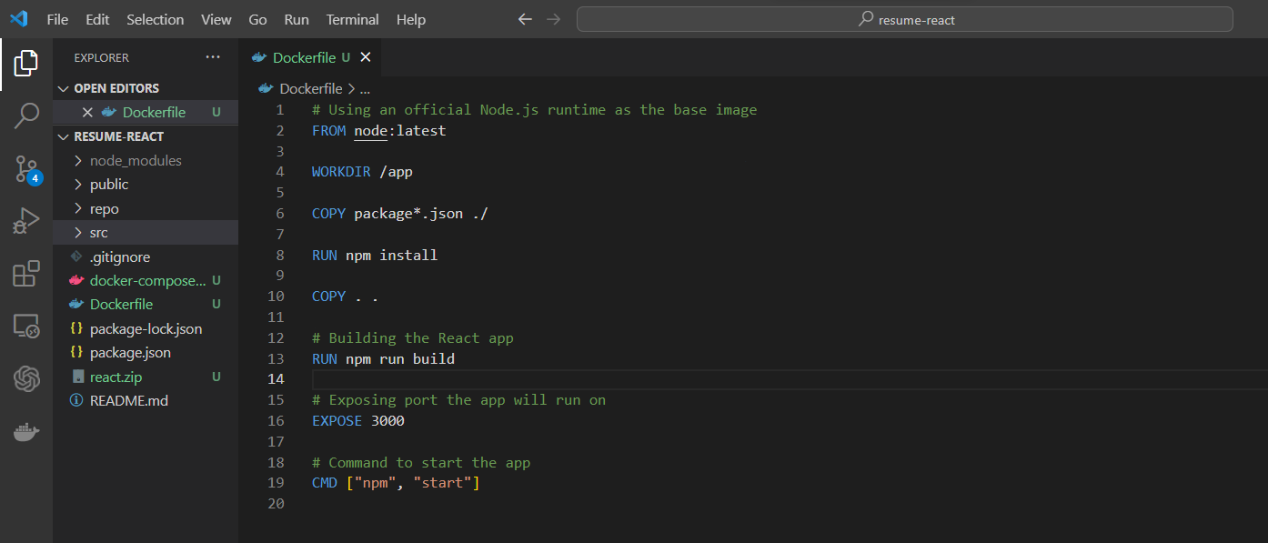

**Yaml File for Compose:** This compose.yaml file uses the image built by the Dockerfile above to deploy the container. Volume mount is specified in the code along with exposing the port number 8000.

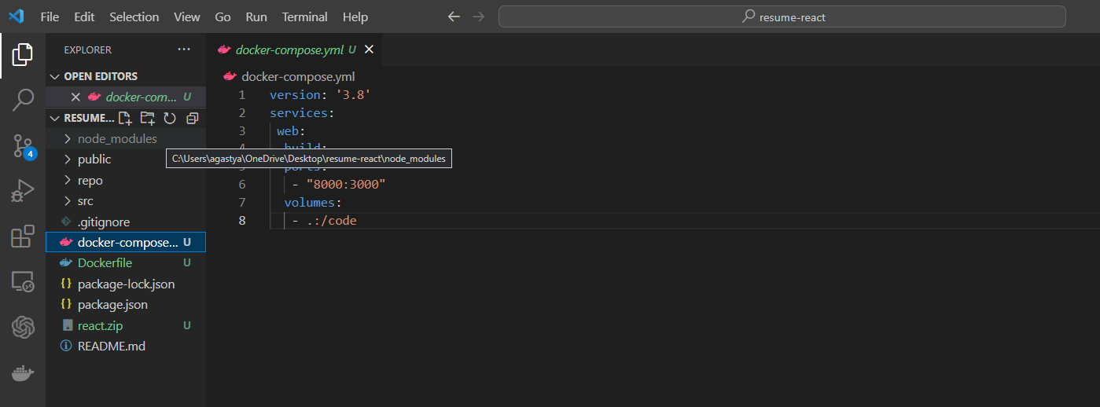

**Before Starting Compose:**

No previous Containers running:

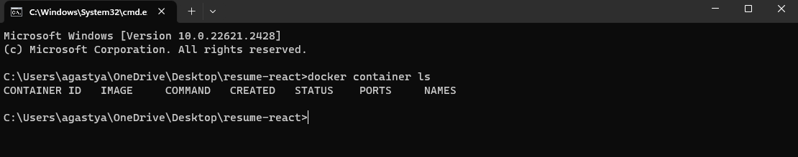

Volumes Before Starting compose:

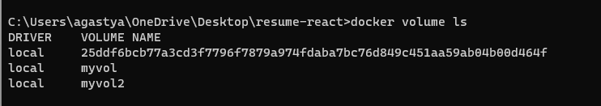

**Starting Docker Compose:** *“docker compose up -d”* (-d is to start it in detached mode, so I can check for changes made by compose.

* Compose building from Dockerfile and layers are exported:

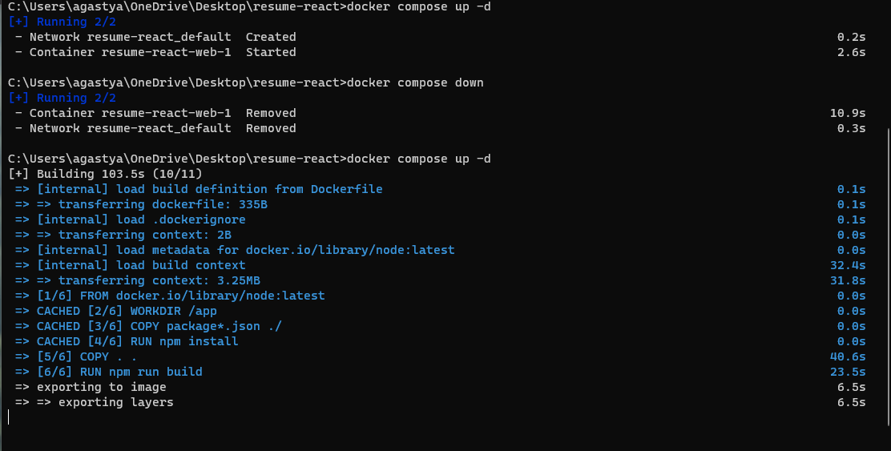

* Network Layer is created by docker compose and containers are started:

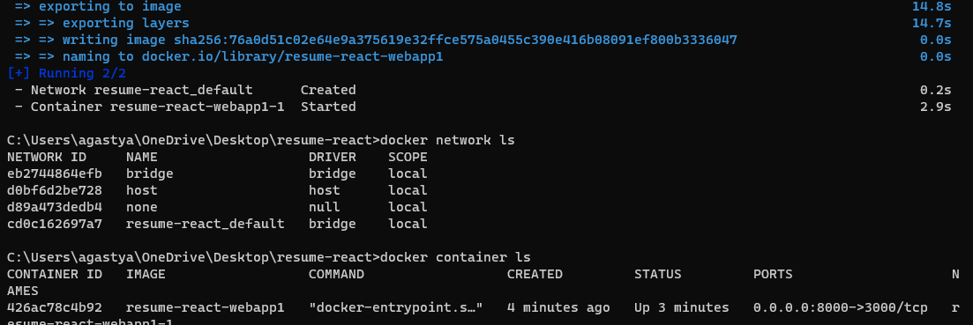

* Checking if the react project is accessible on port 8000 (localhost:8000):

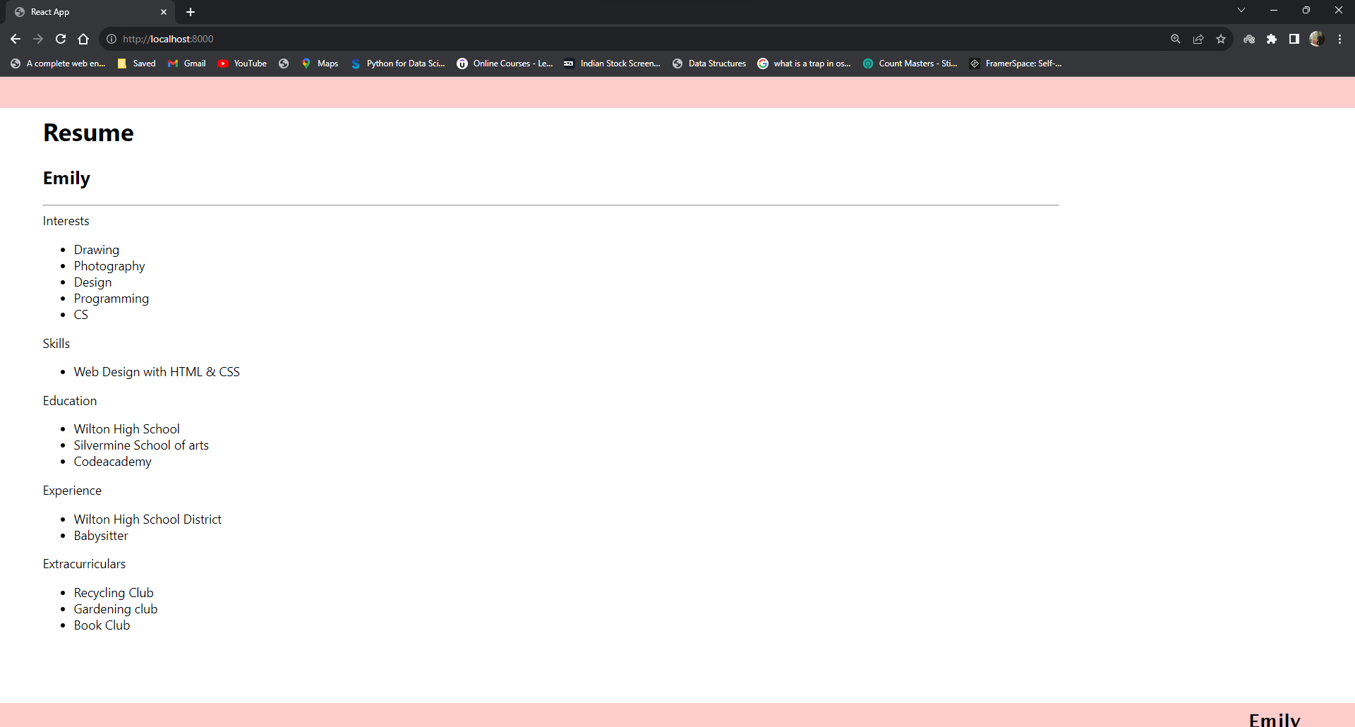

**Project is accessible on port 8000.**